**Project Design Phase-II**

**Data Flow Diagram & User Stories**

|  |  |
| --- | --- |
| Date | 3 AUG 2023 |
| Team ID | LTVIP2023TMID06601 |
| Project Name | Advanced based breast cancer with deep learning |

**Data Flow Diagrams:**

A Data Flow Diagram (DFD) is a traditional visual representation of the information flows within a system. A neat and clear DFD can depict the right amount of the system requirement graphically. It shows how data enters and leaves the system, what changes the information, and where data is stored.

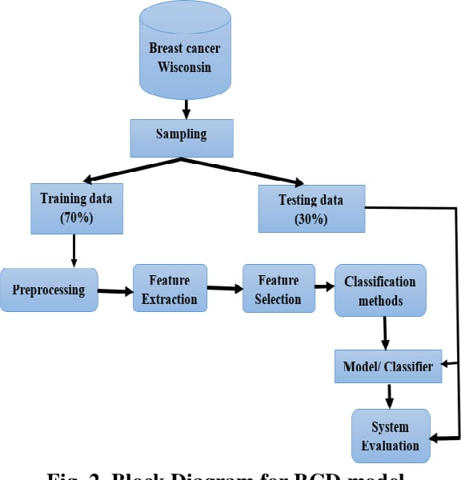

**User Stories**

Use the below template to list all the user stories for the product.

| **User Type** | **Functional Requirement (Epic)** | **User Story Number** | **User Story / Task** | **Acceptance criteria** | **Priority** | **Team Member** |
| --- | --- | --- | --- | --- | --- | --- |
| Customer (Mobile user) | Registration | USN-1 | As a user, I can register for the application by entering my email, password, and confirming my password. | I can access my account / dashboard | High | gayathri |
|  |  | USN-2 | As a user, I will receive confirmation email once I have registered for the application | I can receive confirmation email & click confirm | High | jayasuriya |
|  |  | USN-3 | As a user, I can register for the application through Facebook | I can register & access the dashboard with Facebook Login | Low | visali |
|  |  | USN-4 | As a user, I can register for the application through Gmail | I can register through gmail | Medium | alagarsamy |
|  | Login | USN-5 | As a user, I can log into the application by entering email & password | Give login using otp | High | jayasuriya |
|  | Dashboard | USn-6 | I cannot download result after image processed. | I need history option in my dashboard | high | visali |
| Customer (Web user) | login | USN-7 | As a user I login every time in browser | Give the keep me signed in option. | high | gayathri |
|  | Multiple login | USN-8 | Need multiple device login option | I need this option for download my result. | medium | alagarsamy |
|  | Doctor recommendation | USN-9 | Give doctor recommendation | Give perfect doctor | medium | jayasuriya |
| Customer Care Executive | Need importance | USN-10 | Give importance for both customer | Improve in customer care | low | visali |
| Administrator | advertisement | USN-11 | Make advertisement | Spend in advertisement | medium | Gayathri |